# CS 255 Business Requirements Document Template

## System Components and Design

### Purpose

*What is the purpose of this project? Who is the client and what do they want their system to be able to do?*

* Liam is the client and owner of DriverPass.
* DriverPass is a company centered around preparing new drivers before they attend their DMV tests.
* Liam wants the system to allow users to take online classes and practice tests as well as schedule driving lessons of varying package types at their request.

### System Background

*What does DriverPass want the system to do? What is the problem they want to fix? What are the different components needed for this system?*

* DriverPass wants the system to schedule customers for driving lessons, issue online lessons, practice tests, and take necessary information from customers as needed.
* DriverPass would also like to be able to print reports concerning scheduling changes. These reports should contain information about new reservations, updates to reservations, and cancellations including who created, updated, and/or canceled the reservations.
* DriverPass needs to operate on a cloud server with access online or offline, however, changes can only be made while online to mitigate potential data redundancy.
* DriverPass needs to allow customers to automatically update/recover passwords for their online accounts as needed.
* Driverpass needs to stay up to date on DMV requirements via direct communications with the DMV on matters such as rules, policies, or sample questions. DriverPass should be automatically notified when these communications are made.
* DriverPass should also acquire pertinent information from customers such as first and last name, address, phone number, state, and credit card credentials; a pickup and drop-off location should also be obtained form the customer as needed, the two locations should match.
* DriverPass interface should contain pages that display customer information, business information, and course status for each user individually.
* Progress needs to contain the following information: either “in progress” or “completed”, test name, time taken, user score, and status.
* The courses status should be displayed as “in progress”, “passed”, “failed”, or not taken.
* The overall problem that DriverPass wants to fix is the failing rate of drivers who take their driving tests with the DMV. It has been noted that online practice exams typically are not good enough at preparing new drivers and DriverPass wants to take advantage of the market in this area by providing better tools to new drivers.

### Objectives and Goals

*What should this system be able to do when it is completed? What measurable tasks need to be included in the system design to achieve this?*

* System needs to allow user to create an online account, register for courses and practice tests, and driving lessons if desired.
* System needs to allow secretarial users update customer information and requests as needed as well as create new reservations.
* The system needs to display package options to users and allow them to pick what fits their needs best.
* Measurable tasks to be included are as follows: use case diagrams, activity diagrams, user interface research, and class diagram. Once approved by customer, build interface and link DB to interface, then build business logic before testing the system.

## Requirements

### Nonfunctional Requirements

*In this section, you will detail the different nonfunctional requirements for the DriverPass system. You will need to think about the different things that the system needs to function properly.*

#### Performance Requirements

*What environments (web-based, application, etc.) does this system need to run in? How fast should the system run? How often should the system be updated?*

* System will be cloud based so users can access the site over the web.
* System will respond within 10 seconds of selecting options.
* System will update immediately when new features are added.

#### Platform Constraints

*What platforms (Windows, Unix, etc.) should the system run on? Does the back end require any tools, such as a database, to support this application?*

* All platforms including mobile platforms will be able to run this application.
* The mobile browser will adapt to the user’s chosen interface.

#### Accuracy and Precision

*How will you distinguish between different users?* *Is the input case-sensitive? When should the system inform the admin of a problem?*

* Users will have their own personalized sign on credentials and roles specifying their access level.
* User passwords will be case sensitive, all other input is not case sensitive.
* Crash reports will be sent to admins immediately upon detection of an error.

#### Adaptability

*Can you make changes to the user (add/remove/modify) without changing code? How will the system adapt to platform updates? What type of access does the IT admin need?*

* User will be able to sign up for their own account and then update/change information as necessary via their personal login.
* The system will undergo updates as necessary to coincide with platform changes.
* The IT admin will have full access to the system and server database.

#### Security

*What is required for the user to log in? How can you secure the connection or the data exchange between the client and the server? What should happen to the account if there is a “brute force” hacking attempt? What happens if the user forgets their password?*

* User will create personalized username and password attached to an email account or phone number.
* Data encryption will be used to secure user data when connecting to the server.
* In the case of a hacking attempt the account will be disabled and the user will need to contact IT support to recover their data securely.
* In the case the user forgets their password they will be able to reset it using an authentication system regarding a short time passcode sent either to their registered email or phone number.

### Functional Requirements

*Using the information from the scenario, think about the different functions the system needs to provide. Each of your bullets should start with “The system shall . . .” For example, one functional requirement might be, “The system shall validate user credentials when logging in.”*

* The system shall validate users upon logging in.
* The system shall send identity verification to users via mobile device or email.
* The system shall track and schedule appointments upon user request.
* The system shall prompt the user to reset password after so many failed log in attempts.

### User Interface

*What are the needs of the interface? Who are the different users for this interface? What will each user need to be able to do through the interface? How will the user interact with the interface (mobile, browser, etc.)?*

* The interface will be web based.
* The interface will be viewable via desktop or mobile application.
* Customers will have access to their purchase information and history i.e. in progress courses, completed courses, upcoming courses.
* Administration will be able to make appointments on the customers behalf.

### Assumptions

*What things were not specifically addressed in your design above? What assumptions are you making in your design about the users or the technology they have?*

* Most users will have access and be able to utilize the system with their email address.

### Limitations

*Any system you build will naturally have limitations. What limitations do you see in your system design? What limitations do you have as far as resources, time, budget, or technology?*

* Accessibility for some users depending on their circumstance or location.
* Compatibility with all browser windows.

### Gantt Chart

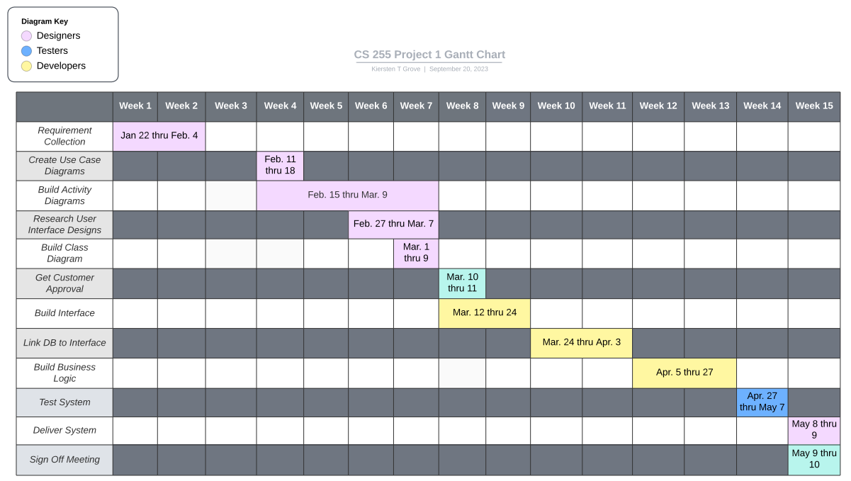*Please include a screenshot of the GANTT chart that you created with Lucidchart. Be sure to check that it meets the plan described by the characters in the interview.*